 | David Michael Cain O'Dougherty
7/22/2016
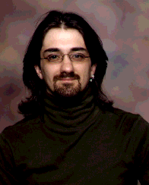 | 9135 S. Mo. 39, Box 821, Stockton, Mo. 65785  816.518.8804  CainO@KCLAI.net / CainO@SpamArrest.com  www.KCLAI.com / www.CainO4Hire.com

Objectives
Explore new horizons, be home more and learn new things
Education
North Kansas City High School (AVTS)
1994
Field of Study: Building & Trades, Architecture
experience
Truck Driver | Coal City Cob, Co.
Sept. 2011 – Pres.
Over the road HazMat tanker driver
skills
- Besides transportation since 1995, I have a small I.T. business on the side, I study alternative health, alternative energy, astrology, psychology, philosophy, theology, organic farming, and more…
- I have Moon in Libra, so I am almost always on a self-improvement campaign. I have Mercury and Mars in Virgo, so I am analytical and enjoy learning. I believe in Quality over quantity.
- I am a people person, so my mother is surprised I have been able to drive truck as long as I have. I am humble, hospitable and a diplomat.
- I am not afraid of much. Not afraid of heights, I can operate heavy equipment. I understand many things tech. I am not the fastest learner, but I can figure out most things. I am an analytical.

